**Our senses are lost online: Investigating how aesthetics might be used to ground people in Cyberspace**

**Key words:** Aesthetics, visualisation, problem solving, perception, sensation, affective, experience design

**Introduction**

Human senses have evolved to pick-up on sensory cues (e.g., colours, textures, sounds, distances, etc.) in a range of aesthetically distinct physical domains (e.g., land, sea, air, etc.) to ensure safe navigation through, and often existence within these spaces. However, in the global village of *cyberspace*, people are unable to use their senses to ground themselves; we have not yet developed the sense of the cyberspace aesthetic as to what affords personal safety. Indeed, straying into the dark and potentially dangerous areas of the internet is becoming an escalating problem and without the necessary grounding, there is the increasing possibility for ill-informed decision-making on where best to navigate and exist in cyberspace. The current paper explores the effect of aesthetical components and grounding on the navigation of information in a graphical map type problem. In doing this, we hope to uncover new meaning and significance for the design of the cyberspace environment to ensure that individuals can make safe decisions online.

**There are no signposts in Cyberspace**

*“Cyberspace, like the Americas, has been proclaimed the “new world”. A new world however, is always posed as the correlate and other of an old world. In this way the new world is situated under the conceptual domination of the old.”* [12]

The term *cyberspace* was coined by William Gibson, who used it in his book, Neuromancer (1989). Gibson [11, pg. 128] defines cyberspace as "a consensual hallucination”. Cyberspace also describes the virtual environment of the Internet [19], alongside its more whimsical portrayal as a global village [12]. The Internet has become ubiquitous, available to anyone with a device and connection, easier to find than clean drinking water in some countries. Beyond being easily accessible, it is constantly accessible, and is increasingly remoulding our social realities, the way we communicate, and the way we behave [1]. Certainly, cyberspace is an area of information that does not correspond with the physics of the environment in which our bodies spend time, and when interacting in this environment we become almost desensitised to our physical surroundings [20]. By entering into the world of cyberspace, we change the way we find one another, communicate with one another, participate, interact, and work with one another [6]. Though it has been observed that “humans and other animals are remarkable in their ability to navigate through complex, dynamic environments” [10, pg.67], this statement refers principally to our sensed physical world. The following question arises: can we adapt traditional real-world navigation techniques to fit cyberspace or, more crucially, can cyberspace be designed to fit with us? Given the new space, and potential dangers, can an active process, requiring mental engagement and attention to the environment one is trying to navigate (aka *wayfinding* [3, 7]) be nurtured?

*Real* environments are described in terms of the distances, sizes, shapes, and orientations of objects and surfaces [10]. Wayfinding through these environments involves “the consistent use and organisation of definite sensory cues from the external environment” [17, pg.6]. These cues can ground (i.e., give someone a basis or benchmark to support decisions) and include visual sensations such as colour, shape, depth and motion, as well as other sensory cues. These can also incorporate a sense of gravity, and possibly even electric or magnetic fields [17]. A *real world* environment that is intelligible not only offers scope for greater personal security but also heightens the potential depth and intensity of Human experience [17].

During the Middle Ages in the UK, there were no signposts or GPS; to find their way from one place to another, people relied on human co-operation to navigate effectively over a distance [2]. In cyberspace, we have medieval roads; once again neither signpost nor GPS exist, and no single person knows all of the routes across the vast and growing space. To compound this problem, cyberspace provides an alien sense of time and distance. Unsurprisingly, humans become disembodied in cyberspace and this quickly changes how they think, feel and behave [1]. In their Atlas of Cyberspace [Dodge & Kitchin] described cyberspace as ‘an enormous and often confusing entity’ that not only impacts on social, cultural, political and economic aspects of everyday life but also can be difficult to monitor and navigate through. [Dodge & Kitchin] spent five years exploring rich and varied visual representations of Cyberspace’s diversity, structure and content to help to further improve understanding on and navigation within cyberspace. More recently,  *[Legg, pg.1]* discusses the importance of situation awareness in cyberspace (i.e. the perception and comprehension of the current situation, and the projection of future status); He feels that the challenge lies in facilitating the user’s understanding of cyber security concerns through effective visualization. To begin to breakdown this challenge, the authors of this paper believe that humans need the power to *sense* their way in cyberspace, they need appropriate cues to inform and support their decisions as they move in and through the space.

**Aesthetic Grounding and the Senses**

The ancient Greeks described the *aesthetic* as the ability to receive stimulation from one or more of our five bodily senses, basically as sensation. Pragmatically, aesthetics facilitate an engaged interaction through the use of sensual stimuli [9]. Taking advantage of the wide knowledge base regarding visual properties in aesthetically experiences [16], this research is looking to bring into cyberspace the intense focus, strong emotions, and active reflection afforded by the aesthetic, and draw on an individual’s senses, intuitions, past experiences, and intellect to make sense of an environment or situation.

The visualisation of information has traditionally been very much about enhancing the user’s interaction with information [21]. A functional visualisation should present the information in a way that engages the viewer’s attention, facilitates reading of the data and enables the user to detect underlying patterns and trends. The key outcome is that the visualisation relieves cognitive burden and speeds up processing and interpretation [5]. Nevertheless, the progress made in information visualisation has occurred at different speeds for sciences, and arts with little discourse between the fields [14]. The current research is interested in the interplay between the aesthetic, cognitive, and affective processes in problem solving (i.e. making sense of a visualisation). In particular, how (if) the intake of aesthetic information in a problem space can influence or change the understanding of how to get to the solution. As Lang [15, pg.6] points out, aesthetics has “to be recognized as not just being a by-product of science (for example like all these nice images of mathematic fractals) but an integral part of science.”

In his thought-provoking paper "Feeling and Thinking: Preferences Need No Inferences” [22], Zajonc discusses the possibility that the very first stage of the organism’s reaction to stimuli and the very first elements in retrieval are affective. Zajonc [22] claims that it is possible for us to like something or be afraid of it before we know precisely what it is and perhaps even without knowing what it is. Since then, many researchers have explored what has become known as automatic affective processing; the idea that organisms are able to determine whether a stimulus is good or bad without engaging in intentional, goal-directed, conscious, or capacity demanding processing of the (evaluative attributes of the) stimulus [13]. In terms of the cyberspace aesthetic, we are designing for the creation of a relationship between the user and the space that encapsulates “a person’s full relationship – sensory, emotional and intellectual” [18] and in doing so, entices an engaged interaction which can change the user’s perceptions and interpretations of the situation. It is true that there is an element of unpredictability around the aesthetic, but this unpredictability opens up many exciting doors for the design of cyberspace. As [4, pg.1] highlighted “the role of the artist [designer] is not so much to construct the artwork but rather to specify and modify the constraints and rules used to govern the relationship between the audience.”

**Study**

This study, which took place at Melbourne University in October 2017, aims to give some insight into individuals’ understanding of a problem space and how aesthetics might affect this. One hundred and twelve psychology students between the ages of 18-30 years completed the study. The study was conducted using the Qualtrics online survey software; thisarticle presents how a thematic analysis was used in the analysis of the online survey data. Participants were presented with a series of problems: graphically represented map type problems of six cities presented in six different graphics (see fig.1). Participants were asked to find the *optimal* route through the map, and to subsequently clarify what they interpreted as *optimal*. After each randomly presented set graphics, participants were asked about the strategies they used for solving the problem, and the thoughts they experienced during it. The questions ranged from factual to open ended questions. The open-ended questions included:

* *What strategies have you applied to enable you to determine the optimal route between A to Z?*
* *In your opinion, what did the elements presented in this graphic mean?*
* *What did you understand by the term optimal route? Did that understanding change across the different graphics?*

The study took approximately forty minutes in duration and followed a standard within-subject design with each graphic generated using *Adobe Fireworks* *CC* software. By undertaking a thematic analysis, the aim was to allow for flexibility to concentrate on specific areas of interest while also revealing other emerging areas. It is envisioned that the process of exploring participant’s experiences of solving the problem (i.e. finding the optimal path) will produce a potential hypotheses for further study, particularly concerning the design of the cyberspace environment to ensure that individuals can make safe decisions online

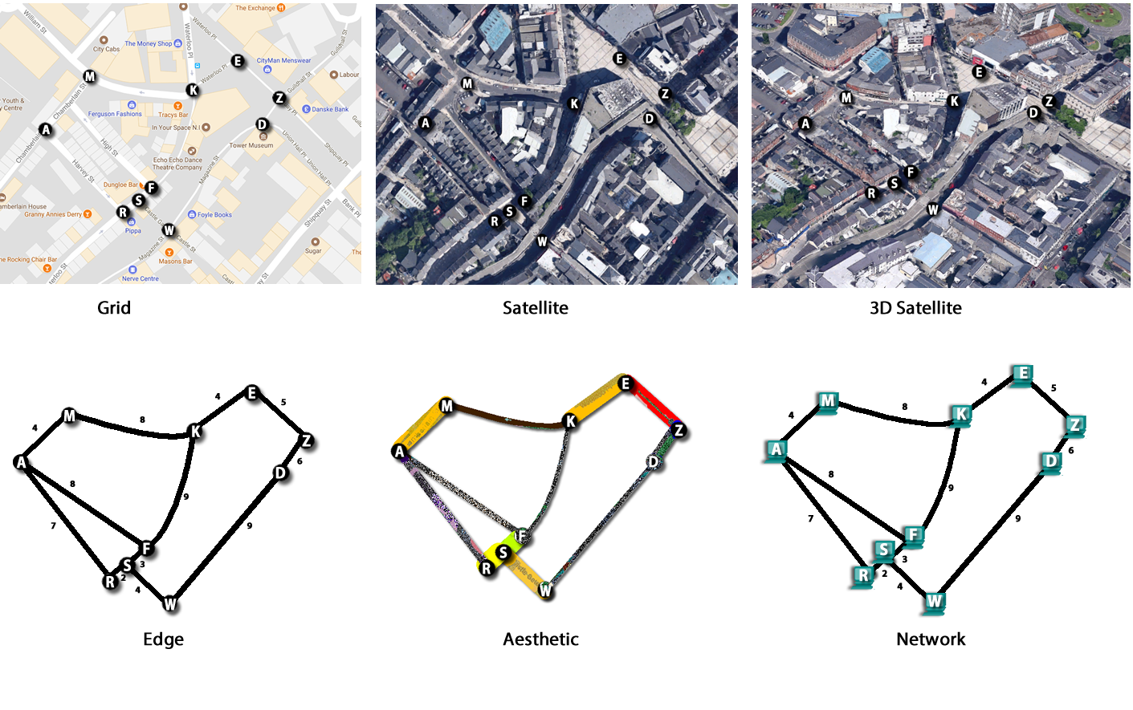

**Fig 1** **Graphically presented map type problems**

**Results**

The experimenter-defined *optimal* solution was the quickest pathway. [1] This solution was similarly arrived at for the majority of the cities tested (five of six). In terms of ease of processing, participants reported the grid graphic was the easiest graphic to work out the optimal path on, and also the most preferred (33% participants ranked the grid as their most preferred graphic, 14% preferred the node graphic, and 10% preferred the aesthetic ). The 3D satellite and the aesthetic graphic were perceived as the most difficult to interpret for optimal solution.

The tendency to outline the predicted (shortest) path was significantly different between graphical representations *F*(4.21, 462.89) = 34.73, *p* < .001 (see fig. 2 for illustration of average number selecting predicted path across cities). The shortest path was followed most frequently in the Edge graphic. The frequency with which the shortest path was selected was significantly higher in the Edge graphic compared to the grid (mean difference = .12, *p* < .001), Satellite (mean difference = .18, *p* < .001), 3D satellite (mean difference = .27, *p* < .001) and aesthetic (mean difference = .15, *p* < .001) graphics, but not the network graphic (mean difference = .02, *p* = 1.00), which had a similarly high average of individuals who selected the shortest route using it. Similarly, the participants selected the shortest route using the network graphic, with a significant higher rate of shortest route chosen in the Network graphic compared to the grid (mean difference = .01, *p* = .02), satellite (mean difference = .16, *p* < .001), 3D satellite (mean difference = .25, *p* < .001), and aesthetic (mean difference = .17, *p* = .001) graphics. The 3D satellite graphic provided the least number of instances in which participants selected the shortest route, with the rate being significantly lower than the grid (mean difference = .16, *p* < .001), satellite (mean difference = .01, *p* < .001), and aesthetic (mean difference = .13, *p* < .001) graphics.

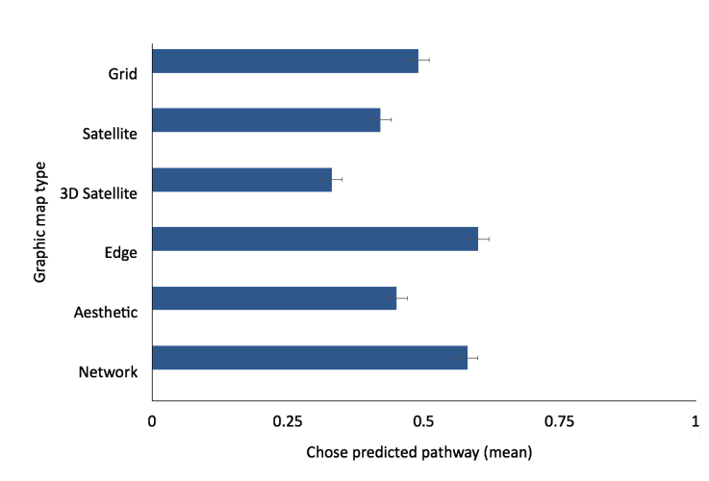

**Fig. 2** Illustration of average number selecting predicted path across cities

However, the above is an indication of the shortest path, rather than the subject-defined optimal path. We therefore use a qualitative approach to further investigate the differences across the different graphics. Figure 3 highlights that the words *route, shortest,* and *distance* appeared most frequently in the data gathered from participants answers to the question: *What strategies have you applied to enable you to determine the optimal route between A to Z?* For all six graphics, it is demonstrably justified that the strategies were concerned with some form of working out of the shortest route or the route with the shortest distance. Also, *numbers* were of clear importance to participants’ strategies in the edge and network graphics whilst other words similar in meaning to *shortest* such as *least,* *smallest*, and/ or *lowest* were found in all graphics except the satellite graphic.

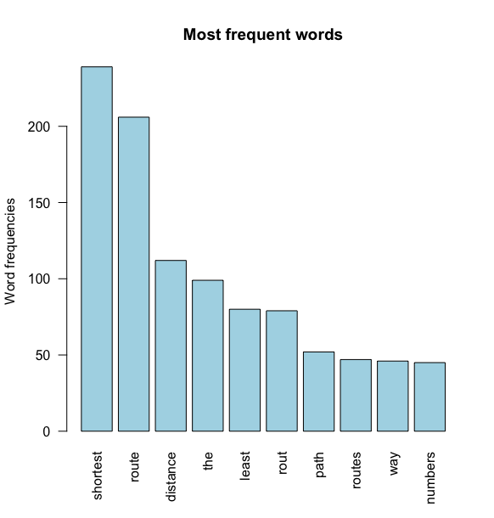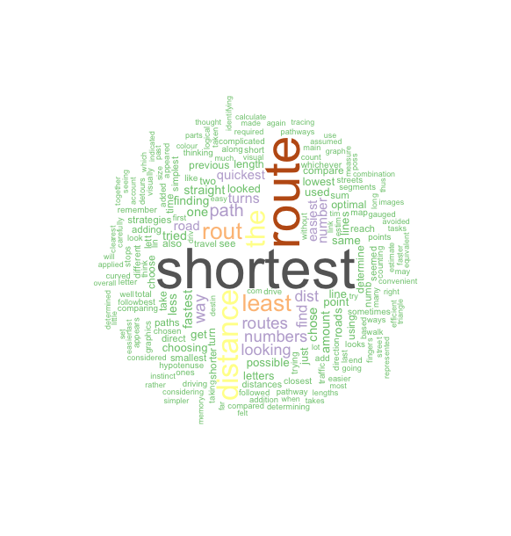

**Fig. 3:** Word frequency count regarding words used across the six graphics

By conducting a thematic analysis to further probe the strategies implemented by participants, a number of themes (e.g. analysis, gut feeling, and embodiment) emerged. Participants seemed to take an analytical approach to solving the problem, trying to make sense of the elements in each of the problem spaces in order to work out the solution. For example, participants developed strategies to work out: the shortest route, the route with the least turns, the route with the most straight-lines, the route with the least distance and the cleanest route etc. As the following comments demonstrate, some graphics afforded more straightforward analytical access than others:

*Find the closest route to as the crow flies, keeping in mind road direction.* **(Participant in the grid graphic)**

*I used spatial reasoning to differentiate between domestic and public land in order to determine which route is optimal.* **(Participant in the satellite graphic)**

*Using my fingers to trace the paths. I also carefully looked at the images to see if there is an actual route or not but sometimes it is far too difficult to assume whether if there was a viable route or not especially on more crowdier looking images.* **(Participant in the 3D satellite graphic)**

*Assuming that the numbers adjacent to the lines indicate the length of the line, the sum of each possible pathway was calculated and the pathway with the lowest value was selected.* **(Participant in the edge graphic)**

*thinking about fastest way to get from a to z. looking at the cleanest route. I was drawn to the wider lines, brighter colours, route that felt faster overall* **(Participant in the aesthetic graphic)**

*I added the numbers together for each possible route and chose the route with the lowest number, which to me represented the shortest route*. **(Participant in the network graphic)**

Though the analytical approach to problem solving was predominately used, there was also the distinct use of intuition, instinct, and gut feelings when participants described the strategies used to solve the problem:

*I used my intuition to find out what route takes less distance like the previous parts.* ***(Participant in the grid graphic)***

*sometimes i just picked the routes that seemed least complicated i.e. with less checkpoints/changes in direction, but sometimes the number of letters in between didn't actually indicate a shorter route. I think I just followed my instincts* ***(Participant in the satellite graphic)***

*observing, intuition* ***(Participant in the 3D satellite graphic)***

*Hypotenuse of triangle, simplicity of route. Eyeballing route and following gut.* ***(Participant in the edge graphic)***

I chose whichever was the quickest whilst also being less complicated (having less turns/changes in direction) I mostly used my instinct ***(Participant in the aesthetic graphic)***

*Intuition* ***(Participant in the network graphic)***

There was also evidence that participants were imagining or trying to embody themselves in the problem space in order to solve the problem:

*I imagined I was a cyclist this time - thus avoided going against traffic (i.e., avoided one-way streets that were in the opposite direction to where I was heading). I tried to stick to the route of shortest distance and fewest turns.* ***(Participant in the grid graphic)***

*Tracing out the most logical path. I imagined myself walking through the street and thinking of which way I would go.* ***(Participant in the satellite graphic)***

*Attempted to picture myself at A trying to get to Z and which route I would take* ***(Participant in the 3D satellite graphic)***

*Thickness of each line represented the sturdiness of the track. People who choose the thicker lines may be dependent on support and not as self-assured so they require a sturdy track while others who are confident with their decisions and path in life choose the thinner lines.* ***(Participant in the aesthetic graphic)***

While participants tended to seek embodied solutions in the grid, satellite, 3D satellite, and aesthetics graphics, the edge and network number graphics highlighted very little or no evidence of applying this embodying strategy to solving the problem. Interestingly, when asked *“In your opinion, what did the elements presented in this graphic mean?”* we can see again that the word *numbers* was quite relevant for participants in the edge and the network graphics but clearly did not appear in the top ten most frequent words from the other graphics. The word *Colour* features and was of significance only in the aesthetic graphic (see table 1) and initially it was found to be confusing for many participants:

*I have no idea what the colours were supposed to represent*

*I’m not sure what the colours and thickness meant.*

In comparison, the *numbers* in the edge and network graphics were much more transparent:

*The elements were the numbers that indicated distance*

*The numbers were possibly the time that it takes to traverse the space between each relevant point*

Participants used the representational geographical features available in the grid, satellite and 3D satellite graphics, referencing these with words such as *map, street, road* and *building*. Interestingly, the participants note *roads* in their interpretation of the aesthetic, as well as the geographically representational satellite graphics, but also tend to use the word *line/s,* which appears in the edge, the network as well as the aesthetic graphic. In view of this, it is important to note that participants in the aesthetic graphic were seemingly taking on board both the representational (road) as well as the more abstract (line) elements in their quest to find meaning. Indeed, while participants were making sense of similar elements in all graphics (e.g., *route, point, letters* etc.), there were clear differences in the impressions being formed. In summary, the main elements in the grid, satellite and 3D satellite graphics were more representational in character (i.e. *map, street, road* and *building*) whist the edge and the network graphics (line, numbers, distance etc.) were clearly more abstract. As highlighted, the aesthetic graphic is seen to have some leanings across both.



**Table 1** Q2. *In your opinion, what did the elements presented in this graphic mean*? The top ten most frequent words.

Participants’ understanding of the “optimal route” were similar to the predicted (i.e., shortest) route outlined by the experimenters: When asked, *“What did you understand by the term optimal route? Did that understanding change across the different graphics?”* the two most frequent words to appear from a word frequency analysis of the data across all graphics include *route* and *shortest*. The word *fastest* appears in all graphics except the aesthetic graphic whilst *distance* is a concept that features in the grid, edge/node, aesthetic and network/numbers graphic only.

Participants’ understanding of the optimal route (i.e., shortest route) did not change across the different graphics. Participants nevertheless made concerted and varied effort into making sense of the varying graphical elements. For example, in the edge graphic, participants calculated the numbers whilst in the aesthetic graphic, there was an obvious conflict and initial confusion around the elements, simultaneously found meaning for each element.

*I thought that the thicker lines provided a sort of terrain (i.e. grass, concrete, etc.) for the route compared to the thinner ones. Along with this, the different colours were different variations of the same terrain (i.e. tall grass, short grass).*

*The lines with different colour and thickness might represent traffic and road conditions, e.g. red means very crowded, thin lines represent narrow streets, thick means spacious.*

*The colour present the condition of the route such as red colour represent crowded.*

*The colours might show different types of traffic, e.g. heavy or light.*

*The colour seems like represent if this route has traffic problem. In my mind, the red usually represent the traffic jam.*

*The colour mean the crowded and busy street. Red means traffic jam.*

The data retrieved from these open-ended questions identified a range of new questions not previously fully conceptualised. These include how design might nurture both intuitive and analytic approaches in problem solving, and incorporate the benefits of embodiment in a problem space. It also highlights the immediate impact of elements such as colour, scale, and texture in wayfinding.

**Conclusion**

As humans, we take cues on how to act and behave from the physical environment we are in. However, cyberspace does not have the same depth of physical cues, and it is possible that, due to people’s inability to ground themselves in a physical and time-oriented world, they have become more disinhibited and disembodied [8]. This study inspected varying graphical elements in problem solving, as well as the way that participants engage and interact with those elements. Graphics that mapped familiarly physical surrounds (e.g., satellite images) encouraged embodied approaches to problem solving, whereas graphics that were parsed back encouraged analytic and mathematical approaches to problem solving. While this study is a first step in investigating aesthetics in a problem space, much more work is needed. Further studies are being developed to investigate various graphical and aesthetic elements in isolation within the problem space. We envision the findings from these studies will build towards a deeper understanding of the role of the aesthetic in the problem space and how it might used to ground people with a sense of personal safety in cyberspace.

**References**

1. M. Aiken. (2016). The Cyber Effect: A Pioneering Cyberpsychologist Explains How Human Behavior Changes Online. Spiegel & Grau.
2. V. Allen & R. Evans (2016). Roadworks: medieval Britain, medieval roads.
3. C. Calori & D. Vanden-Eynden (2015). Signage and Wayfinding design. Wiley Publishers.
4. L. Candy & E. Edmonds (2002). Interaction in Art and Technology. Crossings: eJournal of Art and technology. 2. (1). (Online) Available from: http://crossings. tcd.ie/issues/2.1/Candy/ (19/02/2018).
5. S. Card & J.D. Mackinlay & Shneiderman (Eds.) (1999). Readings in Information Visualisation using Vision to Think. USA: Morgan Kauffmann Publishers.
6. G. Cartwright (1994). Virtual or Real? The mind in Cyberspace. The futurist.
7. N. Cheng, (1998). Wayfinding in cyberspace. Negotiating connections between sites. CAADRIA '98 : Proceedings of The Third Conference on Computer Aided Architectural Design Research in Asia. eds. T. Sasada, S. Yamaguchi, M. Morozumi, A. Kaga, and R. Homma. April 22-24, 1998. Osaka University, Osaka, Japan. Pp. 83-92
8. J. Davidson et al. (2017). Enhancing Police and Industry Practice. Available from: <https://www.mdx.ac.uk/__data/assets/pdf_file/0017/250163/ISEC-report-FINAL.pdf> (19/02/2018)
9. J. Dewey (1934). Art as Experience. London: The Berkley Publishing Group.
10. B.R. Fajen & F. Phillips (2013). Spatial Perception and Action. In Handbook of spatial cognition by Nadel, L. & Waller, D. APA Books, 2013
11. W. Gibson. (1989). Neuromancer. New York: Berkley Publishing Group. pp. 128.
12. DJ. Gunkel & AH. Gunkel (1997). Virtual geographies: The new worlds of cyberspace. In critical Studies in Mass communication 14, 123-127.
13. D.J Houwer & D. Hermans (2001) Automatic affective processing, Cognition & Emotion, 15:2, 113-114, DOI: 10.1080/02699930125900
14. G. Judelman (2004). Aesthetics and Inspiration for Visualization Design: Bridging the Gap between Art and Science. In: Eighth International Conference on Information Visualisation, 14-16th July, London, UK. Los Alamitos, California: IEEE Computer Society. Pp.245-250. (Online). Available from: http://www. gregjudelman.com/media/judelmanIV04paper.pdf (21/02/2018).
15. A. Lang (2010) The aesthetics of information visualization. Technical Report, University of Munich, Department of Computer Science. (Online) Available at: <https://www.medien.ifi.lmu.de/lehre/ws0809/hs/docs/lang.pdf> (21/02/2018)
16. H. Leder, B. Belke, A. Oeberst & D. Augustin (2004). A model of aesthetic appreciation and aesthetic judgments. British Journal of Psychology, 95, 489-508.
17. K. Lynch (1960). The image of the city. The technology Press & Harvard University Press. Cambridge
18. J. McCarthy & P. Wright (2004). Technology as Experience. Massachusetts: MIT Press.
19. D. Rajnovic (2012). Cyberspace – What is it? (Online). Available from: <https://blogs.cisco.com/security/cyberspace-what-is-it> (28/02/2018)
20. J. Suler (2004). The online disinhibition effect. Cyberpsychology & behavior,7(3), 321-326.
21. J.S.Yi, Y.A.Kang, , J.T. Stasko, J.A. Jacko (2007). Toward a deeper understanding of the role of interaction in information visualization. IEEE Trans. Vis. Comput. Graph. 13(6), 1224–1231 (2007)
22. R. B. Zajonc (1980). Feeling and thinking: Preferences need no inferences. American Psychologist, 35(2), 151-175

1. Google Maps was used to identify the predicted path (i.e. the quickest route) that was used for the design of this study.